**Breaking Down DC Crime:**

*Data Cleaning:*

The first step we did was to access the CSV file using pandas. We created a dataframe after reading the file to help us choose what information needed to be dropped from the DF. After dropping columns, we counted how many values were in each column to clear any rows that had data missing.

*Questions:*

Question 1:

What method of crime is used most across many years in DC?

-Using a line graph, I was able to find that Gun and Knife crime types were fairly consistent over the years in DC. The rest of the crime is categorized as “others,” meaning there was not a weapon used. Other crimes seemed to increase steadily between the years 2008 and 2013. In 2014 it dipped a little and stayed consistent the following year. In 2016, it dropped again.

What type of crime is most common across many years in DC?

-Using a line graph, I was able to find that non-violent crimes were much more common than violent crimes. For the most part, violent crimes stayed consistent over the years without dropping too much. Non-violent crimes increased at a steady rate until 2013, then dropped. This is in line with method of crime across DC. Gun & Knife are considered violent and their numbers are similar.

Question 2:

At what time of day is crime most likely to happen?

-To find when crimes are most likely to happen, bins were created for certain hours during the day. After grouping the data and then using a box plot, it is found that crime is most common to occur during the hours of 12 and 5pm, with the second most common being 5pm to 11pm. This makes sense considering more people are out and about around this time of day and heading home from work.

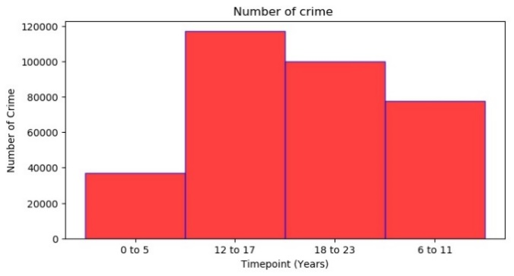

What crime method is most common at certain points during the day?

-To determine what crime type is most common during certain hours, groups were created based on offense time and hour of the day. According to the graph, theft is the most common offense type in every hour group (other than “other”). The second most common is either burglary or robbery. Also, the times of day where crime occurs most matches with the graph showing when it is most likely to happen.

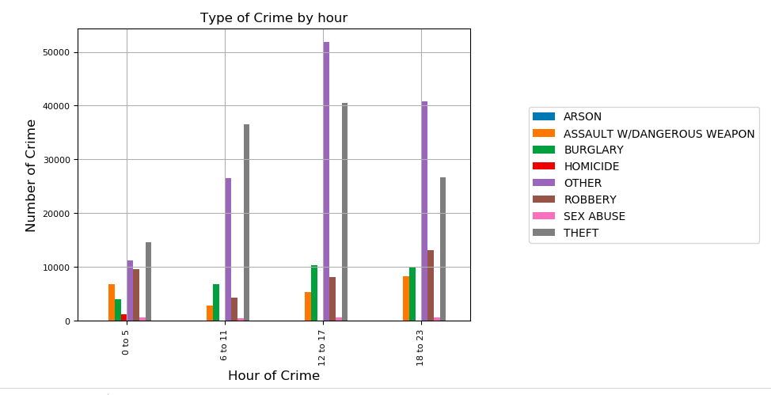

Question 3:

Which district has more crime?

-To determine which district has the most crime over the past few years, I grouped the crimes by district. After that, I created a pie chart which shows what percentage of overall crimes happened in each district. According to the pie chart, district one has the most crime.

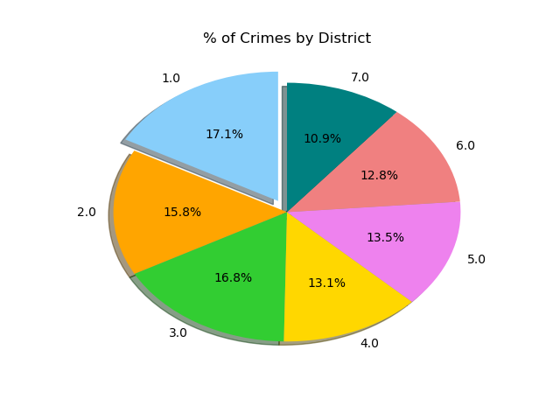

What type of crime is most common in each district?

-After grouping by district, I further grouped by crime type to determine which district had the most violent crimes. It was interesting to see that even though the first 3 districts had the highest number of crimes, district 7 had the most violent crimes.

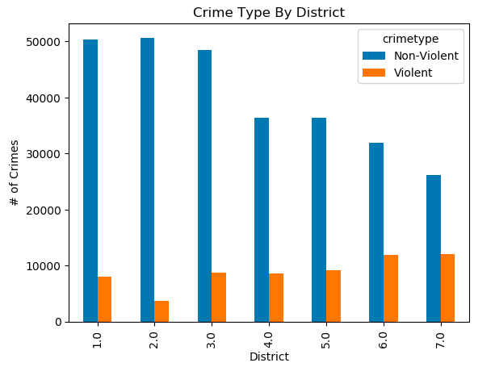

Question 4:

What quad of DC has the most crime?

-To find which quad has the most crime, I grouped all the crimes by quad. The quad with the most crime was the Northeast. The crime with the least amount was the southwest, most likely because there is not a whole lot of DC considered the southwest.

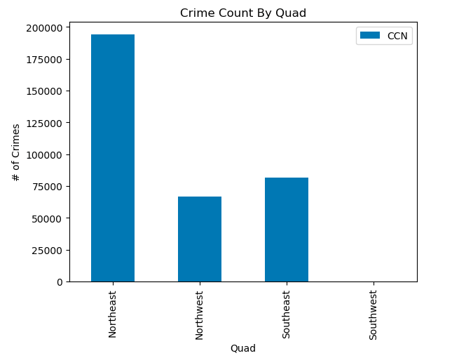

Which quad had the most violent crimes?

-After grouping by quad, I separated them by violent and non-violent crimes. The northeast had the most violent crimes happen, which makes sense considering that area has way more crimes than other areas. Interestingly enough, the southeast almost had as many violent crimes even though they have 1/3 less amount of total crimes.

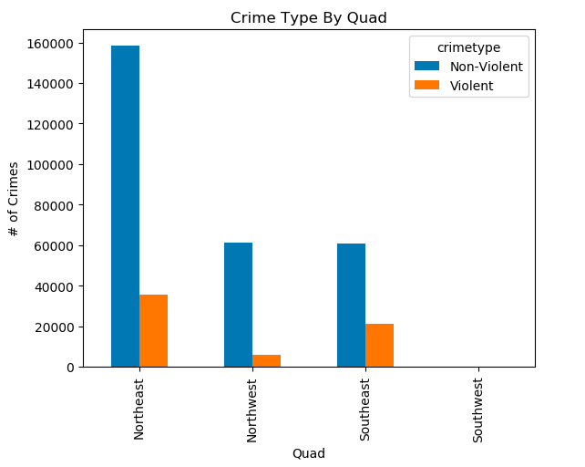

Question 5:

Where on a map do most gun homicides occur?

-Using API, we can find out where homicides that used a gun occur. From the API map, you can see that the NE quad is the most unsafe quad in DC. There are very few dots placed in the SW quad, meaning this is the safest area to live in. This is further proven by the charts above.

